TYPOGRAPHY PRACTICE

Objective:

To master the art of typography by applying font pairing, hierarchy, spacing, and alignment to create visually appealing designs.

Design 1: Minimal Typography

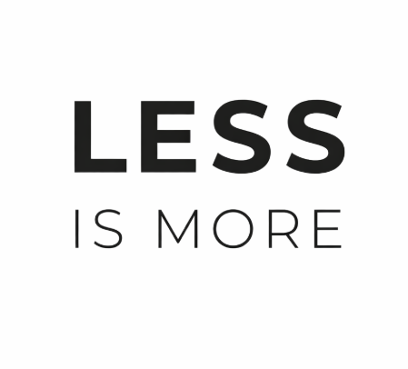
This design uses font hierarchy by making “LESS” bold and large, while “IS MORE” is lighter and spaced. The minimal black and white style enhances clarity and visual impact.

Design 2: Bold Typography
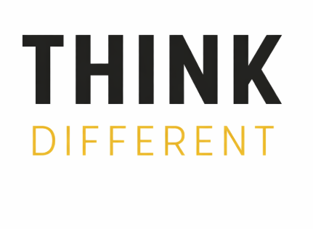
This design demonstrates font pairing and contrast. “THINK” is bold and strong, while “DIFFERENT” uses spacing and color to create emphasis and visual interest.

Design 3: Elegant Typography
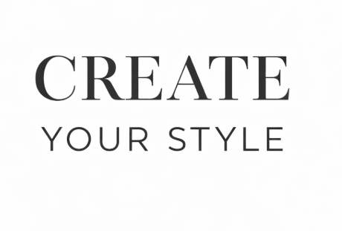
This design combines serif and sans-serif fonts to create an elegant look. It shows balance, readability, and proper alignment.

Tools Used:
Canva

Conclusion:

This task helped in understanding typography principles such as hierarchy, spacing, alignment, and font pairing to create effective visual communication.

